PROJET REPORT TEMPLATE

1. INTRODUCTION

Catering is a service-oriented industry that involves preparing and providing food and beverage services for various events and occasions. Whether it's a wedding, corporate meeting, birthday party, or any other gathering where people need to be served food, catering plays a crucial role in ensuring the culinary and hospitality aspects are well taken care of.

Here's an introduction to catering:

1. \*\*Definition\*\*: Catering is the business of providing food service at a remote location, such as a banquet hall, event venue, or even a private home. It encompasses a wide range of services, from menu planning and food preparation to on-site food service and cleanup.

2. \*\*Types of Catering\*\*:

- \*\*Wedding Catering\*\*: Specializing in providing services for weddings, from the rehearsal dinner to the reception.

- \*\*Corporate Catering\*\*: Catering for business events, including meetings, conferences, and office parties.

- \*\*Event Catering\*\*: Covering a broad spectrum of events, including birthdays, anniversaries, and more.

- \*\*Industrial Catering\*\*: Focused on providing meals to industries, such as factories or construction sites.

- \*\*Social Catering\*\*: Catering for social events like family reunions, holiday parties, and picnics.

3. \*\*Services Offered\*\*:

- \*\*Menu Planning\*\*: Creating a diverse and appealing menu tailored to the event and dietary preferences.

- \*\*Food Preparation\*\*: Skillful cooking and presentation of dishes using quality ingredients.

- \*\*Beverage Service\*\*: Providing a range of beverages, including alcoholic and non-alcoholic options.

- \*\*Service Staff\*\*: Supplying trained wait staff, bartenders, and chefs for on-site events.

- \*\*Equipment Rental\*\*: Offering rental of tables, chairs, dinnerware, and more.

- \*\*Cleanup and Disposal\*\*: Ensuring the event space is left clean and tidy after the catering service.

4. \*\*Challenges and Responsibilities\*\*:

- Maintaining food safety standards.

- Adhering to dietary restrictions and special requests.

- Managing inventory and logistics for ingredients and equipment.

- Coordination with event planners and clients.

- Ensuring the presentation and quality of food meet expectations.

5. \*\*Trends in Catering\*\*:

- \*\*Sustainability\*\*: The use of locally-sourced, eco-friendly, and sustainable ingredients.

- \*\*Customization\*\*: Tailoring menus to individual preferences and dietary restrictions.

- \*\*Global Cuisine\*\*: Offering a diverse range of international dishes.

- \*\*Interactive Food Stations\*\*: Live cooking stations and food experiences for guests.

- \*\*Technology Integration\*\*: Using apps and online platforms for ordering and payment.

In essence, catering is a dynamic and creative industry that combines culinary artistry, event management, and hospitality to provide memorable dining experiences for clients and their guests. Whether for an intimate dinner party or a large-scale corporate event, catering services play a vital role in making occasions special and stress-free.

* 1. OVERVIEW

\*\*Definition\*\*: Catering is a service industry that involves providing food and beverage services at a remote location, typically for events, parties, meetings, and other special occasions. It encompasses a wide range of services related to food preparation, presentation, and service.

\*\*Key Elements\*\*:

1. \*\*Menu Planning\*\*: Caterers work with clients to create customized menus, taking into consideration the type of event, dietary preferences, and budget constraints. The menu may include appetizers, main courses, desserts, and beverages.

2. \*\*Food Preparation\*\*: Caterers are responsible for sourcing high-quality ingredients, preparing the dishes, and ensuring they meet quality and safety standards. This often involves a team of chefs and kitchen staff.

3. \*\*Service Staff\*\*: Catering services often provide waitstaff, bartenders, and sometimes chefs who serve and interact with guests at the event. These professionals are trained to offer a high level of hospitality.

4. \*\*Beverage Service\*\*: Caterers may offer a variety of beverage options, including alcoholic and non-alcoholic drinks. This can include cocktails, wine, beer, soft drinks, and more.

5. \*\*Equipment Rental\*\*: Many catering companies offer rental services for tables, chairs, linens, dinnerware, and other event-related items. They ensure the proper setup of the event space.

6. \*\*Logistics and Coordination\*\*: Caterers are responsible for the logistics of food delivery, setup, and breakdown. They coordinate with event planners, clients, and venue managers to ensure a smooth operation.

7. \*\*Specialization\*\*: Catering services often specialize in certain types of events, such as weddings, corporate functions, social gatherings, or industrial catering. This allows them to tailor their services to specific client needs.

\*\*Types of Catering\*\*:

1. \*\*Wedding Catering\*\*: Specializes in providing services for weddings, including rehearsal dinners, receptions, and more.

2. \*\*Corporate Catering\*\*: Focuses on catering for business events, including meetings, conferences, and office parties.

3. \*\*Event Catering\*\*: Covers a broad spectrum of events, such as birthdays, anniversaries, and other private gatherings.

4. \*\*Industrial Catering\*\*: Provides meals for industries, such as factories or construction sites.

5. \*\*Social Catering\*\*: Caters to social events like family reunions, holiday parties, and picnics.

\*\*Challenges\*\*:

- Ensuring food safety and hygiene.

- Accommodating dietary restrictions and special requests.

- Managing inventory and logistics for ingredients and equipment.

- Adapting to changing client preferences and trends.

- Balancing cost control with delivering high-quality service.

\*\*Trends\*\*:

- \*\*Sustainability\*\*: The use of locally-sourced, eco-friendly, and sustainable ingredients.

- \*\*Customization\*\*: Tailoring menus to individual preferences and dietary restrictions.

- \*\*Global Cuisine\*\*: Offering a diverse range of international dishes.

- \*\*Interactive Food Stations\*\*: Live cooking stations and food experiences for guests.

- \*\*Technology Integration\*\*: Using apps and online platforms for ordering and payment.

In summary, catering is a multifaceted industry that caters to a wide array of events and clients. It involves meticulous planning, creative culinary skills, excellent service, and the ability to adapt to evolving culinary and event trends. Caterers play a pivotal role in ensuring that events are not only well-fed but also leave with memorable dining experiences.

* 1. PURPOSE

The purpose of catering is multifaceted and serves several essential functions, all of which revolve around providing food and beverage services at events and special occasions. Here are the primary purposes of catering:

1. \*\*Provide Convenient Dining Solutions\*\*: Catering simplifies the process of serving food and beverages at events, eliminating the need for hosts or event organizers to handle cooking and serving themselves. This convenience allows hosts to focus on other aspects of the event.

2. \*\*Create Memorable Dining Experiences\*\*: Caterers are often culinary experts who excel in creating memorable and delicious food experiences. They contribute to the overall ambiance and enjoyment of the event by serving well-prepared and aesthetically pleasing dishes.

3. \*\*Accommodate Large Gatherings\*\*: Catering is particularly valuable for large gatherings, where preparing and serving food for a large number of guests would be impractical for the host. Caterers have the resources and expertise to handle such events efficiently.

4. \*\*Customization\*\*: Catering services allow clients to customize their menus to suit their preferences and the theme of the event. This personalization ensures that the food served aligns with the client's vision and meets the dietary requirements of the guests.

5. \*\*Professional Service\*\*: Catering companies often provide trained and experienced service staff, including wait staff and bartenders, who offer a high level of professionalism and hospitality. This enhances the overall guest experience.

6. \*\*Efficient Food Management\*\*: Caterers are skilled in food safety, preparation, and presentation. They ensure that food is prepared, stored, and served safely and in accordance with health regulations.

7. \*\*Logistical Support\*\*: Caterers manage the logistics of food delivery, setup, and cleanup, allowing clients to focus on the event itself. This includes transportation, setup of tables and equipment, and the timely service of food.

8. \*\*Versatility\*\*: Catering services are versatile and can cater to a wide range of events, from weddings and corporate functions to social gatherings and industrial sites. This adaptability makes them suitable for various client needs.

9. \*\*Cost Control\*\*: Catering can often provide cost-effective solutions for events by leveraging their buying power, reducing food waste, and optimizing resources. This can result in significant cost savings for clients.

10. \*\*Support for Diverse Dietary Preferences\*\*: Catering can accommodate various dietary restrictions and preferences, including vegetarian, vegan, gluten-free, and more, ensuring that all guests can enjoy the event.

11. \*\*Time Efficiency\*\*: For clients, catering saves time and effort by handling the extensive planning, preparation, and execution of the culinary aspects of an event. This time efficiency is particularly valuable for busy hosts or event organizers.

In summary, the purpose of catering is to simplify the process of providing food and beverage services for events, enhance the guest experience, and meet the diverse needs and preferences of clients. Caterers play a crucial role in ensuring that events are not only well-fed but also successful and memorable.

2. PRONLEM DEFINITION & DESIGN THINKING

2.1 EMATHY MAP:

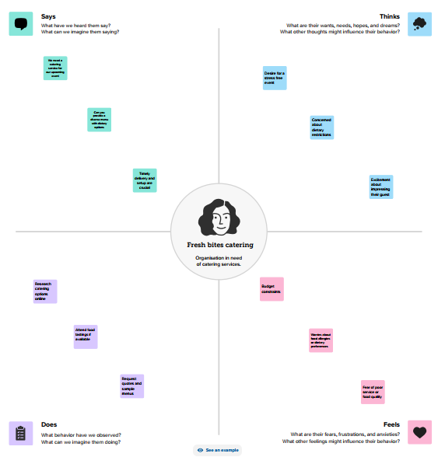

2.2 IDATION & BRANSTORMING MAP:

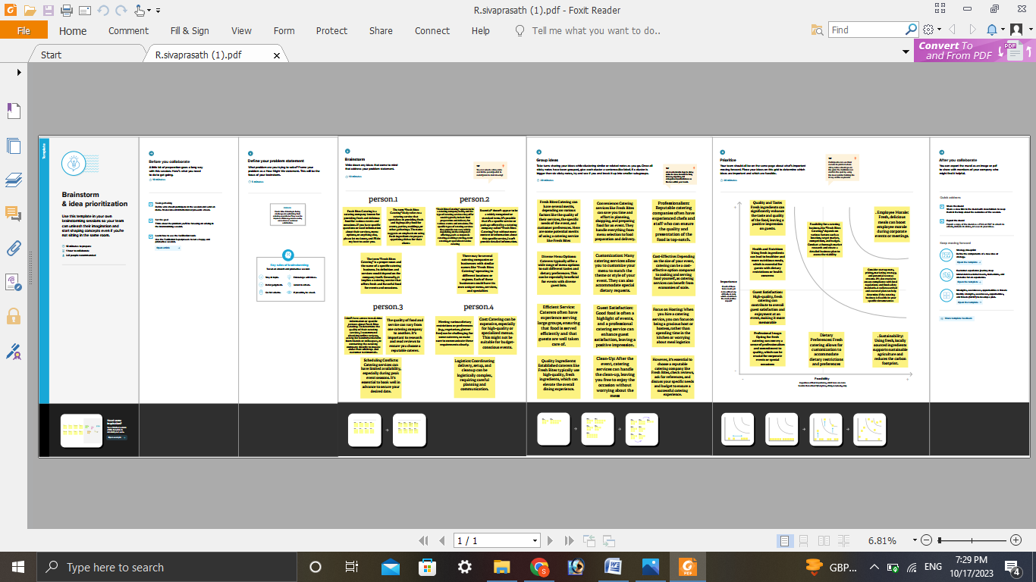

3. RESULT

The taking after functionalities made a difference us within the victory of the project:

Profit & loss

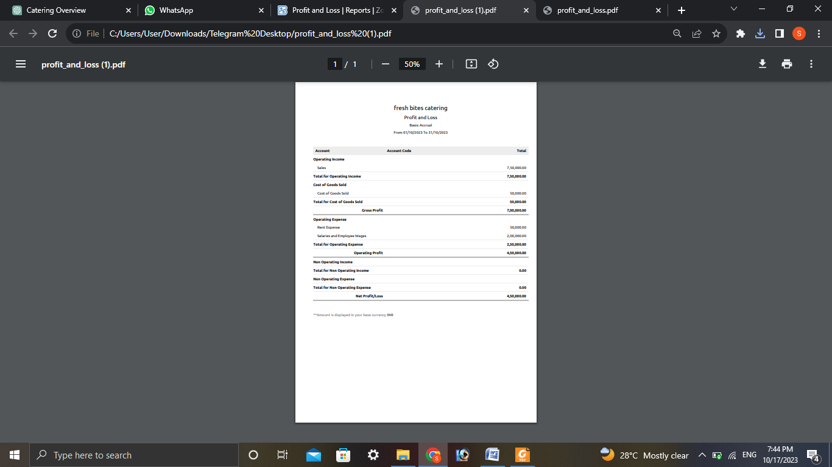

BALANCE SHEET

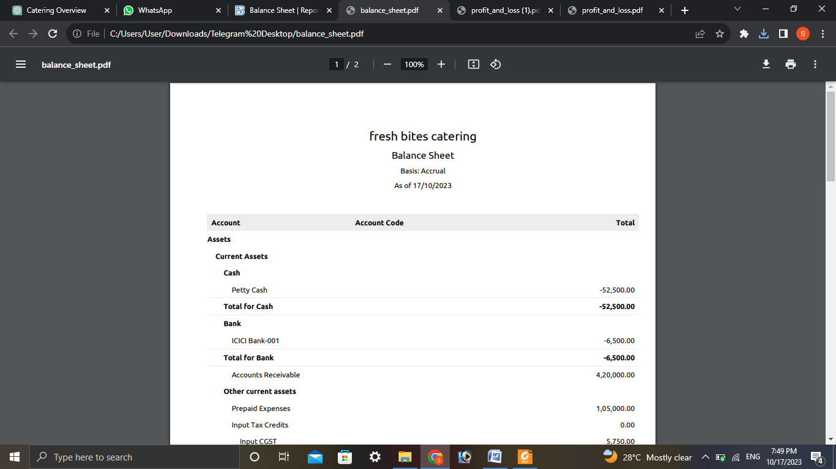

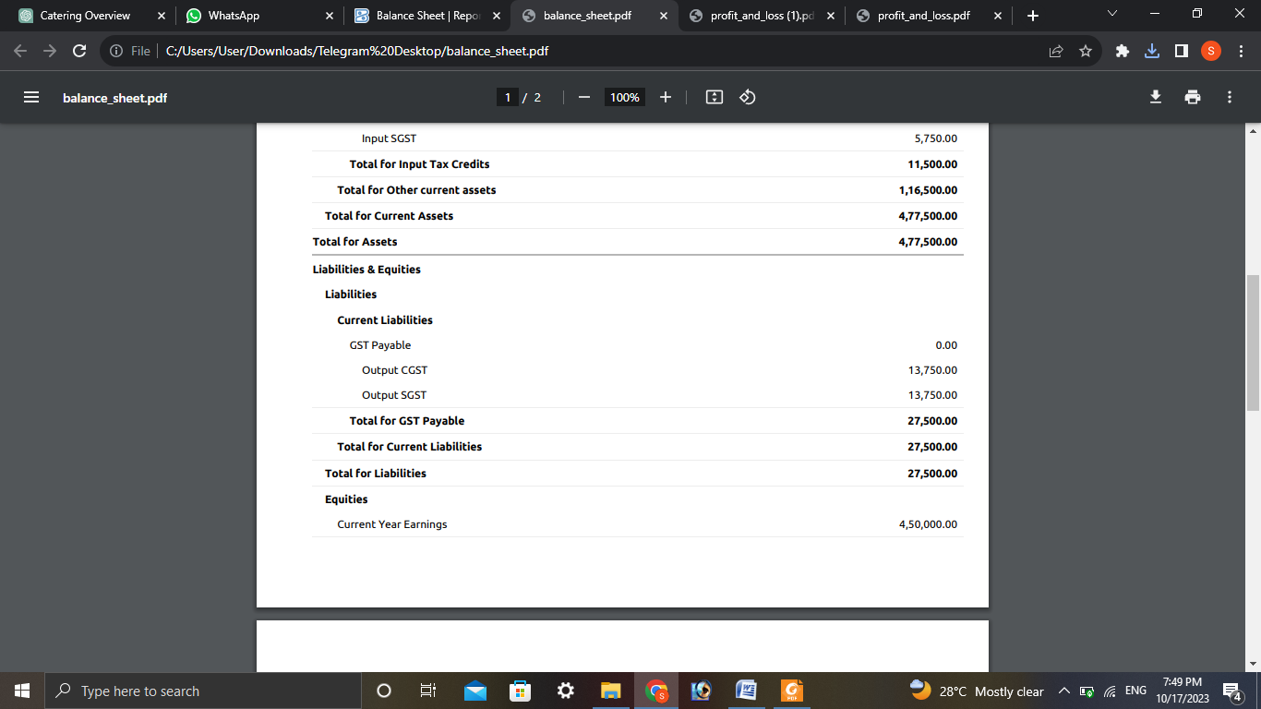

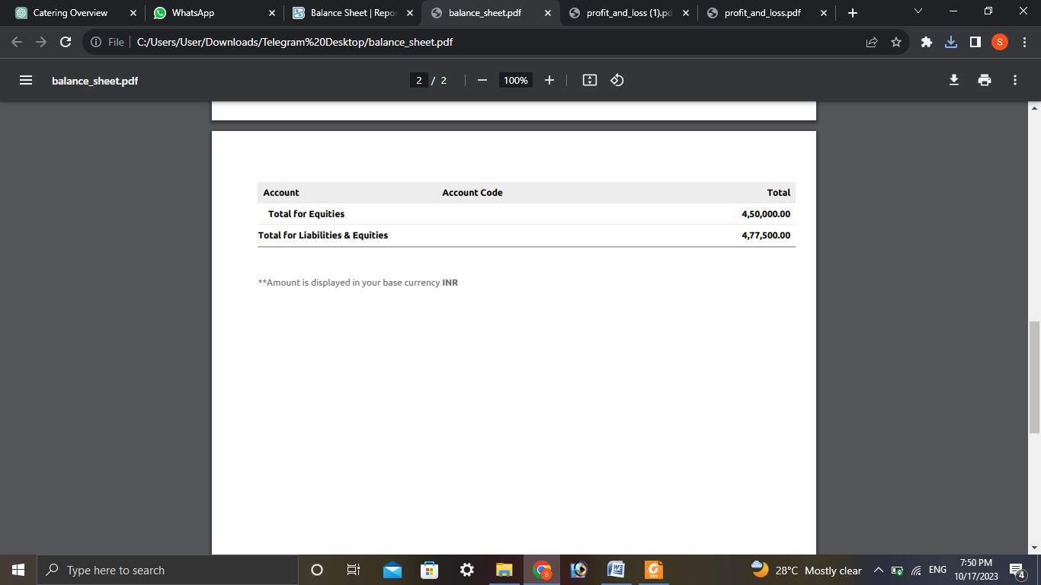

4. ADVANTANGES & DISADVANTANGES

Certainly, catering, like any business or service, comes with its own set of advantages and disadvantages. Here's a breakdown of the pros and cons of catering:

\*\*Advantages of Catering\*\*:

1. \*\*Convenience\*\*: Catering provides a convenient solution for event hosts by taking care of food preparation, service, and cleanup. This allows hosts to focus on other aspects of the event.

2. \*\*Professional Expertise\*\*: Catering companies employ culinary experts who can create delicious and visually appealing dishes, enhancing the overall guest experience.

3. \*\*Customization\*\*: Clients can customize their menus to match their event's theme, dietary preferences, and budget, ensuring a personalized dining experience.

4. \*\*Efficiency\*\*: Caterers are skilled in food management and logistics, ensuring that food is prepared, stored, and served safely and efficiently.

5. \*\*Versatility\*\*: Catering services can adapt to a wide range of events, from weddings to corporate functions, making them suitable for various client needs.

6. \*\*Cost Savings\*\*: Caterers can often provide cost-effective solutions through their buying power, reducing food waste, and resource optimization.

7. \*\*Professional Service\*\*: Catering companies provide trained staff, such as waitstaff and bartenders, who offer a high level of professionalism and hospitality.

8. \*\*Accommodation of Dietary Preferences\*\*: Caterers can accommodate various dietary restrictions and preferences, ensuring that all guests can enjoy the event.

\*\*Disadvantages of Catering\*\*:

1. \*\*Cost\*\*: Professional catering can be expensive, especially for larger events. Costs can quickly add up, including fees for food, staff, equipment, and rental items.

2. \*\*Limited Control\*\*: Clients may have limited control over the preparation and serving of food. They need to trust the caterer to execute their vision correctly.

3. \*\*Communication Challenges\*\*: Miscommunication between clients and caterers can lead to misunderstandings about menu choices, dietary restrictions, and event details.

4. \*\*Dependence on External Services\*\*: Catering relies on external services for delivery, setup, and cleanup, which can sometimes result in unforeseen delays or issues.

5. \*\*Food Quality\*\*: The quality of food can vary between catering companies, and not all caterers may meet the client's expectations in terms of taste and presentation.

6. \*\*Logistical Complexity\*\*: Organizing catering for large events requires careful logistics, and any missteps can disrupt the entire event.

7. \*\*Waste Management\*\*: Catering events can generate a significant amount of food waste, which may be a concern for clients who are conscious of environmental sustainability.

8. \*\*Overhead Costs\*\*: Running a catering business comes with significant overhead costs, including kitchen facilities, equipment, and staff, which can impact the pricing of services.

In conclusion, the decision to use catering services depends on the specific needs and circumstances of an event or gathering. While catering offers many advantages in terms of convenience, professionalism, and culinary expertise, it also comes with potential disadvantages, including costs and the need to place trust in the caterer's ability to meet your expectations. Careful planning, clear communication, and the selection of a reputable catering company can help mitigate some of the disadvantages associated with catering.

5. APPLIAIONS

Certainly, here are some common applications of catering services:

1. \*\*Weddings\*\*: Wedding catering is a popular application, where caterers provide a range of services for wedding ceremonies, receptions, and related events. They create customized menus, offer various cuisine options, and ensure that the culinary aspect of the wedding is memorable.

2. \*\*Corporate Events\*\*: Catering is frequently used for corporate events, including meetings, conferences, seminars, product launches, and company parties. Caterers provide meals, snacks, and beverages to suit the needs of the corporate audience.

3. \*\*Private Parties\*\*: Catering services are often used for private parties such as birthdays, anniversaries, family reunions, and holiday celebrations. They can deliver a wide range of menu options to accommodate different tastes and preferences.

4. \*\*Social Gatherings\*\*: Catering is suitable for various social gatherings, including barbecues, picnics, and community events. Caterers can provide themed menus and set up food stations for a fun and interactive experience.

5. \*\*Industrial Catering\*\*: In industrial settings, such as factories or construction sites, catering services provide meals and snacks to the workforce. They ensure that workers have access to nutritious and convenient food options.

6. \*\*Special Events\*\*: Catering can be applied to special occasions like milestone birthdays, engagements, and baby showers. Caterers help in creating memorable dining experiences that align with the theme of the event.

7. \*\*Funerals and Memorials\*\*: Catering services can offer compassionate support during somber occasions by providing food and beverages for funerals and memorial services, allowing the grieving families to focus on their guests.

8. \*\*Outdoor Events\*\*: Catering is commonly used for outdoor events like picnics, sports events, and concerts. Caterers often serve portable and easy-to-eat foods suitable for these settings.

9. \*\*Institutional Catering\*\*: Catering services are used in educational institutions, hospitals, and care facilities to provide meals for students, patients, and residents. They ensure that nutrition and dietary needs are met.

10. \*\*Catering Delivery\*\*: With the rise of food delivery services, catering can also extend to providing large quantities of food for home or office delivery, particularly for larger gatherings and events.

11. \*\*Cultural and Religious Celebrations\*\*: Catering services play a significant role in cultural and religious celebrations, ensuring that traditional and ceremonial foods are prepared and served with authenticity.

12. \*\*Holiday Catering\*\*: During holidays, catering services can provide special menus and holiday-themed meals for both corporate and private events, making the celebrations more festive.

These are just some of the diverse applications of catering services. Caterers adapt to the specific needs of each event, offering a wide range of menu options, service styles, and culinary experiences to suit various occasions and client preferences.

6. CONCUSION

In conclusion, catering is a dynamic and versatile industry that plays a vital role in providing food and beverage services for a wide range of events and occasions. Whether it's a wedding, corporate meeting, private party, or industrial site, catering services offer numerous advantages, including convenience, customization, and professional expertise. However, there are also challenges to consider, such as costs, the potential loss of control, and the need for clear communication.

Caterers are culinary experts who can create memorable dining experiences, adapting their services to meet the unique needs and preferences of each client. From wedding banquets to outdoor picnics and cultural celebrations, catering services contribute to the success and enjoyment of these events.

Ultimately, the choice to use catering services depends on the specific requirements and goals of the event, as well as the client's budget and expectations. When selected wisely and managed effectively, catering services can enhance any gathering by ensuring that the culinary aspects are well-tailored, safe, and professionally executed.

7. FUTRE SCOPE

The future of the catering industry is promising, as it continues to evolve and adapt to changing consumer preferences, technological advancements, and global trends. Here are some key aspects that highlight the future scope of catering:

1. \*\*Health and Wellness\*\*: As people become more health-conscious, there is a growing demand for catering services that offer healthier menu options. Caterers are likely to focus on incorporating locally sourced, organic ingredients and creating dishes that cater to various dietary preferences, including vegetarian, vegan, and gluten-free options.

2. \*\*Sustainability\*\*: Sustainable practices are becoming increasingly important. Catering companies are expected to emphasize environmentally friendly sourcing, preparation, and waste reduction. Reducing single-use plastics and minimizing food waste will be integral to their operations.

3. \*\*Global and Fusion Cuisine\*\*: The trend of offering diverse and international flavors will continue. Caterers will experiment with global and fusion cuisines, introducing clients and guests to new and exciting dishes from around the world.

4. \*\*Technology Integration\*\*: Technology will play a significant role in catering. Online platforms and mobile apps for ordering, payment, and menu selection will become more common. Caterers may also leverage data analytics to better understand client preferences and optimize their services.

5. \*\*Virtual and Hybrid Events\*\*: The COVID-19 pandemic accelerated the adoption of virtual and hybrid events. Caterers will adapt to this trend by offering virtual catering packages and innovative ways to deliver food to remote participants.

6. \*\*Interactive Food Experiences\*\*: Caterers will create interactive food experiences at events, such as live cooking stations, chef demonstrations, and food and beverage pairings, to engage and entertain guests.

7. \*\*Automation and Robotics\*\*: The use of automation and robotics in food preparation and service may increase to improve efficiency and reduce labor costs. Automated food delivery and self-serve kiosks could become more prevalent.

8. \*\*Delivery Services\*\*: With the rise of food delivery platforms, catering companies may expand their delivery services beyond events to offer prepared meals to individuals and offices, tapping into the growing demand for convenient dining options.

9. \*\*Pop-up Catering\*\*: Pop-up restaurants and catering services, often with rotating themes and concepts, will continue to attract diners looking for unique and memorable dining experiences.

10. \*\*Professionalization and Certification\*\*: The catering industry may see increased professionalism and the development of industry standards and certifications to ensure quality and safety in food service.

11. \*\*Innovation in Presentation\*\*: Caterers will experiment with innovative and artistic ways to present food, including edible art, novel serving vessels, and visually stunning tables capes.

12. \*\*Crisis Response\*\*: Caterers will further develop their crisis management and adaptability, as seen during the COVID-19 pandemic, to be prepared for unexpected challenges.

The future of catering is likely to be shaped by the ongoing emphasis on health, sustainability, technology, and the changing landscape of events. Adaptability, creativity, and the ability to meet the diverse needs of clients will be key factors in the industry's success. Whether for small private gatherings or large corporate events, catering will continue to be an essential part of creating memorable dining experiences.